Duy Nguyen

Assignment 2: Notation

Professor Robert S. Alexander

CMSC 204

**Github**

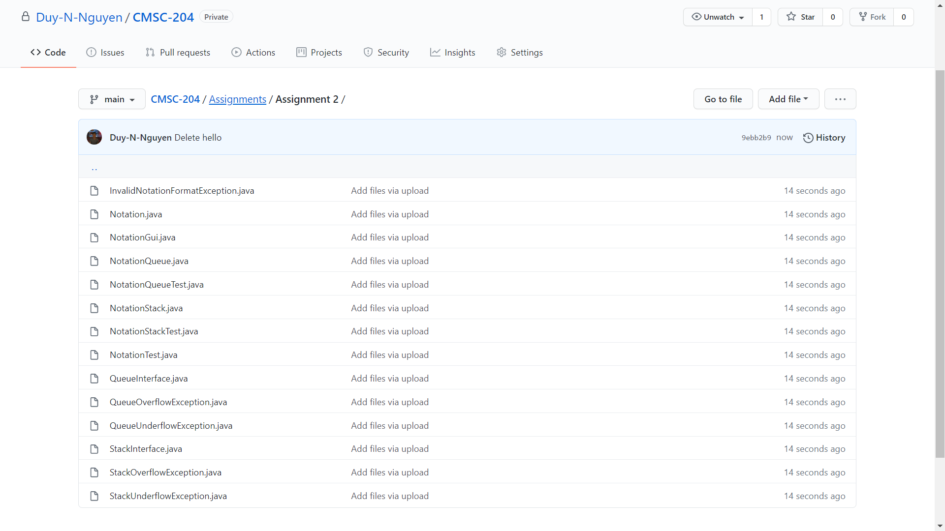

**UML**

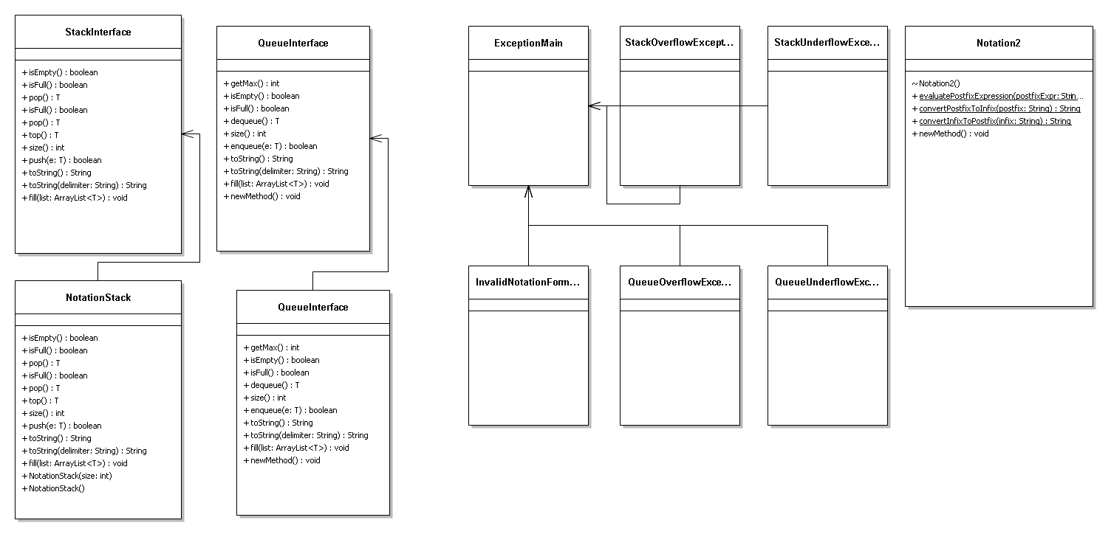

**Junit Queue Test**

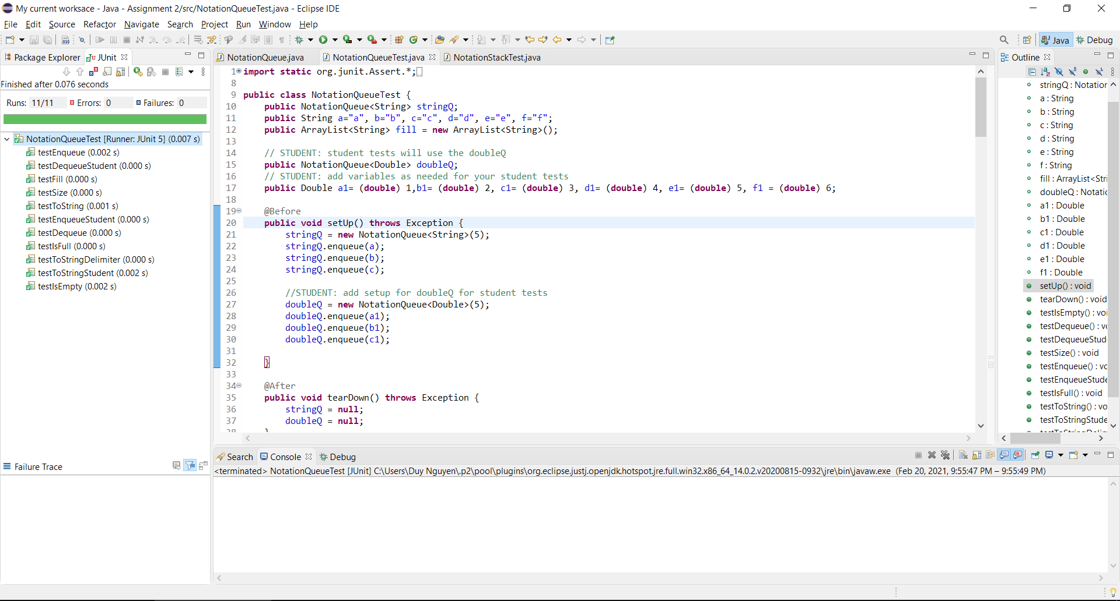

**Junit Stack Test**

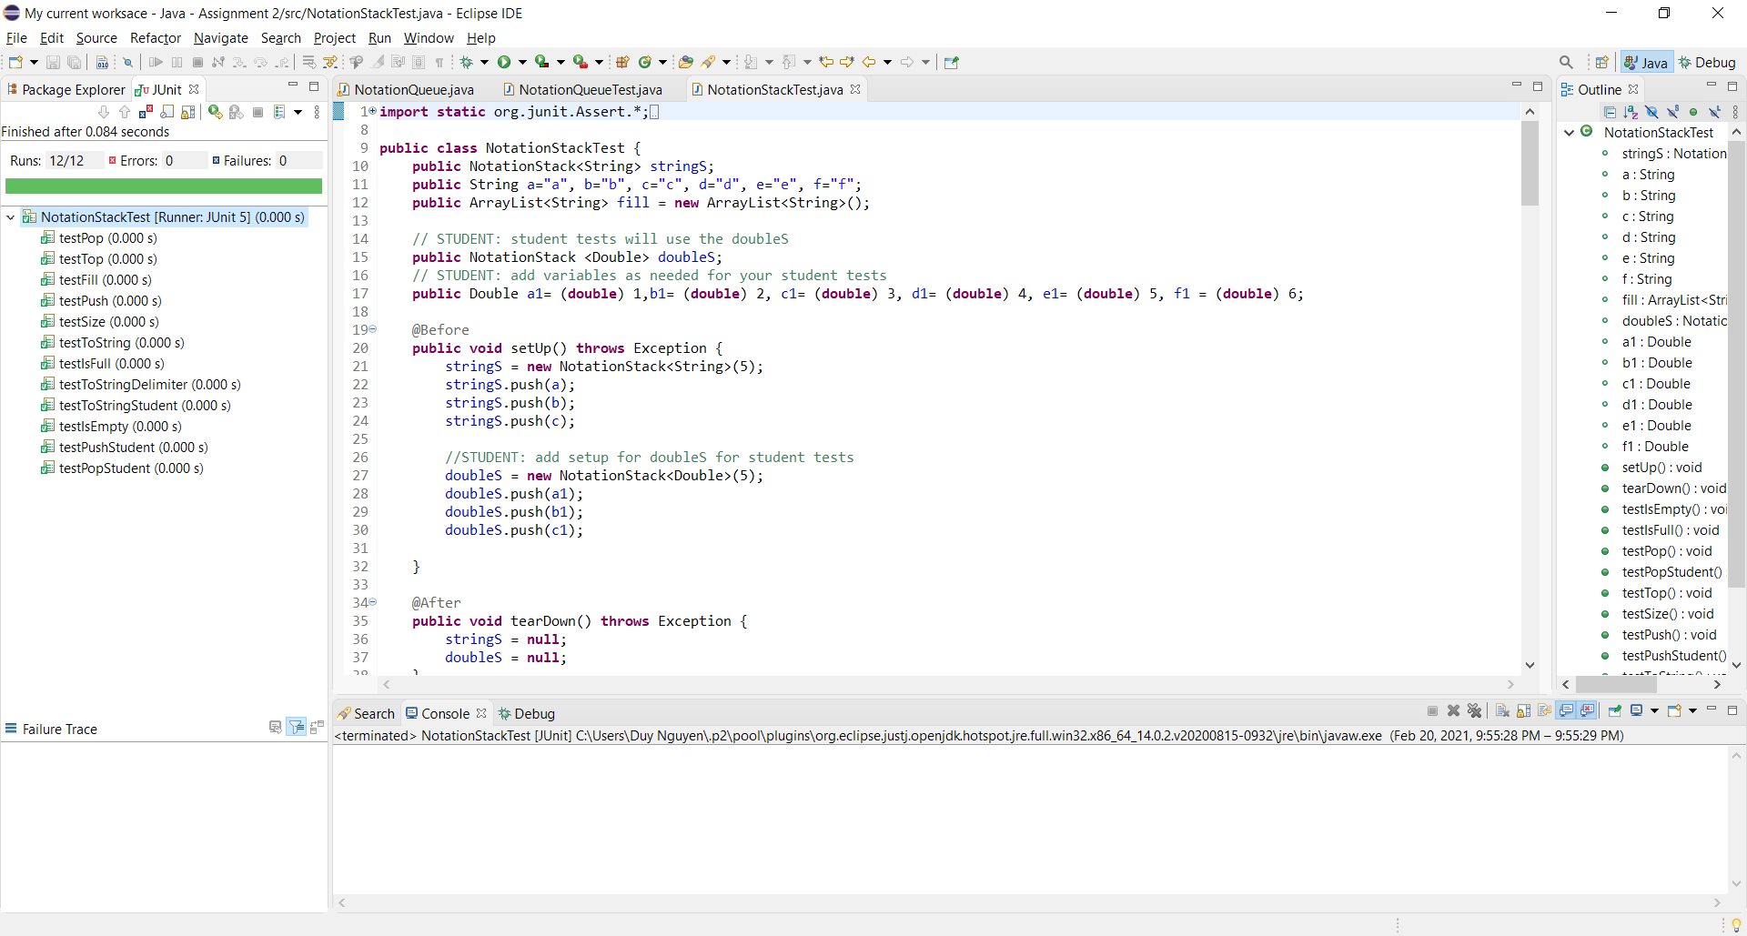

**Junit Notation Test**

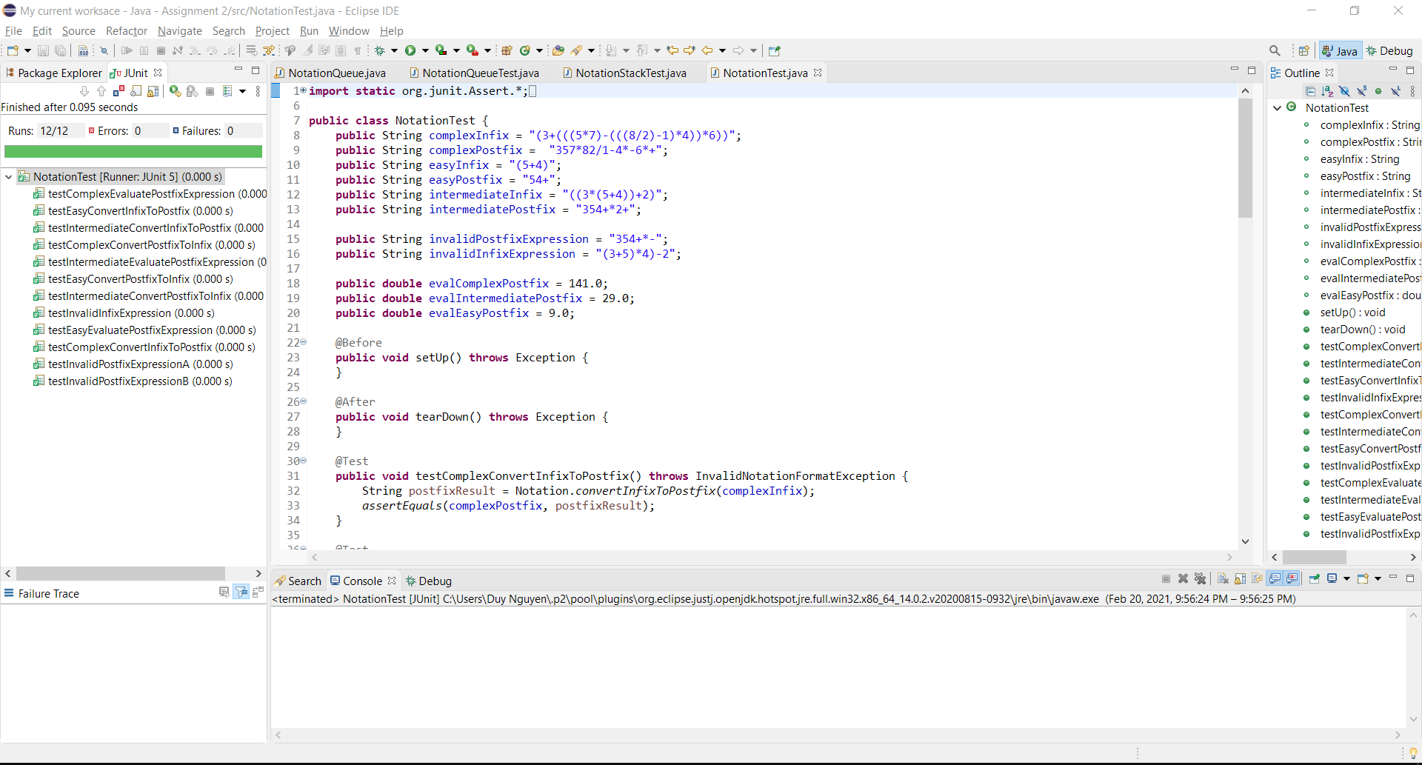

**Learning Experience**

For assignment 2 we were tasked to convert infix to postfix and vice versa using stacks and queues. Some concepts that were also tested were exception handling and generic data types, along with learning how to use stacks and queues. Since there were so many new concepts being used, there was a bit of a learning curve that took quite some time to get over. This assignment is a 10 out of 10 in difficulty, I will not miss this one.

This was the hardest assignment I’ve ever done up until now. Nothing made sense, all the classes relayed on each other and if one didn’t work, none of it worked. The most difficult part for me was learning how to work around generic data types. The lab we worked on the week before wasn’t too much help. I had to learn how to use them in methods and how to initialize them in a constructor, this learning process took about a week of off and on work. After this was done, the rest was smooth sailing. The project literal told you how to do everything so I just followed the steps.

Moving on, I heard this class gets a lot harder. This assignment was a huge struggle for me, everything just seems hard. I am not happy with how long it took me to finish, I needed to get help earlier. I’m glad this project is finally over and looking forward to the next one. Also being in quarantine with working on this project was a nightmare. I was seriously considering giving up on this one and moving on to the next assignment. This project took way to long to figure out even thought all of the algorithms were provided.